|  |  |
| --- | --- |
| **Diploma in Computer Engineering**  **Intelligent Automation (INAUTO)** |  |

Project

**Objective**

To design and develop a standalone Robotic Process Automation (RPA) application using the UiPath Studio platform, demonstrating proficiency in automation techniques and best practices while addressing real-world challenges.

**INAuto Project Proposal Form**

|  |  |  |
| --- | --- | --- |
| Student Name: | **LEE SIANG YIN** | Class: N1 |

Pls tick on the boxes:

Applications Used

|  |  |  |
| --- | --- | --- |
| MS Office App 1 | 🗹 | Outlook |
| MS Office App 2 | 🗹 | Excel |
| MS Office App 3 | 🞏 |  |
| MS Office App 4 | 🞏 |  |
| Web Application 1 | 🗹 | Chrome |
| Web Application 2 | 🗹 | Whatsapp |
| Web Application 3 | 🞏 |  |
| Web Application 4 | 🞏 |  |
| Email | 🗹 |  |
| PDF | 🗹 |  |
| Others, please indicate | 🞏 |  |

**Brief description of your RPA App:**

**Objective:**

To develop a unified Robotic Process Automation (RPA) workflow using UiPath Studio to streamline the processes of tour booking coordination and sending customers notification. The project aims to enhance operational efficiency, minimize errors, and improve customer engagement by automating repetitive tasks and ensuring timely communication. This project highlights proficiency in automation techniques, adherence to best practices, and addresses real-world challenges in tour agency operations.

**Applications use:**

|  |  |  |  |  |
| --- | --- | --- | --- | --- |
| **UiPath Studio** | **Ms Excel** | **Ms Outlook** | **PDF** | **Chrome** |
|  |  |  |  |  |

**Key Features:**

The automation project covers the following functionalities and tasks:

1. **Data Extraction and Integration**: Extract relevant data from pre-existing datasets (Booking, Customer, and Tour agent data). Dynamically merge datasets for specific tasks like PDF generation and reminders.
2. **PDF Generation**: Generate structured PDF with tour and customer details for agents.
3. **Email Automation**: Send emails to tour agents with the PDF attachment containing tour and customer details.
4. **Web Applications Automation**: Automate browser tasks to retrieve weather forecasts and flight terminal information.
5. **Reminder Automation**: Send personalized message reminders to customers via web WhatsApp for upcoming tours.
6. **Reporting and Logging**: Generate detailed summary reports and maintain error logs for auditing and debugging.
7. **Reusable Components**: Implement modular workflows to ensure scalability and reusability.

**Datasets:**

1. **Customer Data**, pre-existing dataset which include fields:

* Customer ID: String
* First Name: String
* Last Name: String
* Full Name: String
* Gender: String
* Date of Birth: Date
* Nationality: String
* Passport No: String
* Passport Expiry Date: Date
* Email: String
* Contact No: String

Customer data sample:

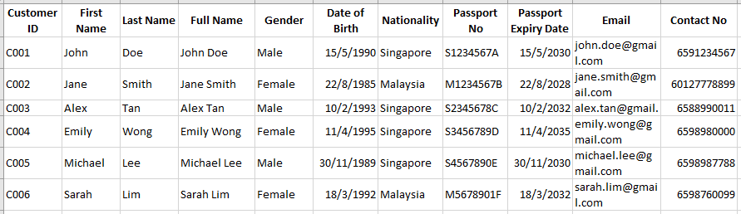

1. **Booking Data**, pre-existing dataset which include fields:

* Booking ID: String
* Booking Date: Date
* Status: String (e.g., 'Confirmed', 'Pending', 'Cancelled')
* Tour ID: String
* Tour Name: String
* Country: String
* Tour Start Date: Date
* Tour End Date: Date
* Customer ID: String
* Room Type: String (e.g., 'SGL', 'DBL', 'TWN', 'TRP')
* Rooming Group: String (e.g., 'SGL-01', 'DBL-02', 'TWN-03')
* Remark: String (e.g., 'Non-smoking room', 'Vegetarian meal')
* Flight PNR: String
* Flight Depart Date: Date
* Flight Depart Time: String
* Flight Depart No: String
* Flight Depart From: String
* Flight Depart To: String
* Flight Return Date: Date
* Flight Return Time: String
* Flight Return No: String
* Flight Return From: String
* Flight Return To: String

Booking data sample:

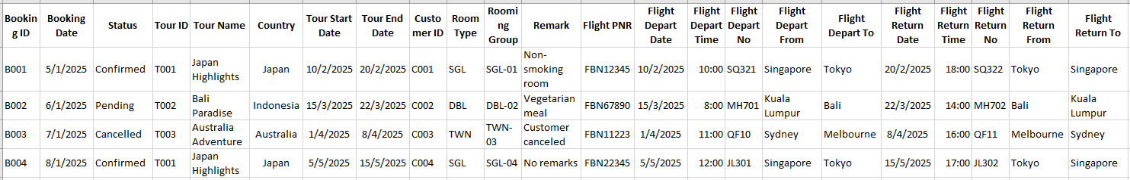

1. **Tour Agent Data**, pre-existing dataset which include fields:

* Tour ID: String
* Agent ID: String
* Agent Name: String
* Agent Email: String
* Agent Contact No: String

Tour partners data sample:

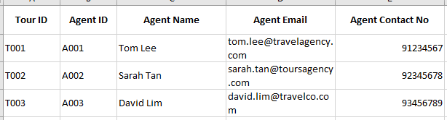

**Workflow Design, Flowchart Design Structure**

**Tour Booking Coordination Workflow Description:**

1. **Input Tour Start Date**
   1. The user inputs a tour start date to extract data for all tours starting on that date.
2. **Data Extraction** 
   1. Query and save the compile data from the existing dataset:
      1. Booking Details: Filter booking data which the tour start date is equal with user input date.
      2. Tour Details: Tour Name, Start Date, End Date, Country, Agent Email.
      3. Customer Details: Customer ID, First Name, Last Name, Gender, Rooming Group, Room Type, Passport Number, Date of Birth and Flight Details (if applicable).
      4. Save the compilation dataset with the [TourId_StartDate_EndDate].
3. **PDF Generation** 
   1. File Name: [TourID_TourStartDate-TourEndDate].pdf
   2. PDF Content:
      1. Tour Information: Tour Name, Start Date, End Date.
      2. Customer List: Index No, First Name, Last Name, Gender, Rooming Group, Room Type, Passport Number, Date of Birth, Flight Details (if applicable).
4. **Email Automation** 
   1. Recipient: Agent Email from the extracted tour details.
   2. Subject: [Tour Booking Details] Tour Name: [Tour Name]
   3. Body:

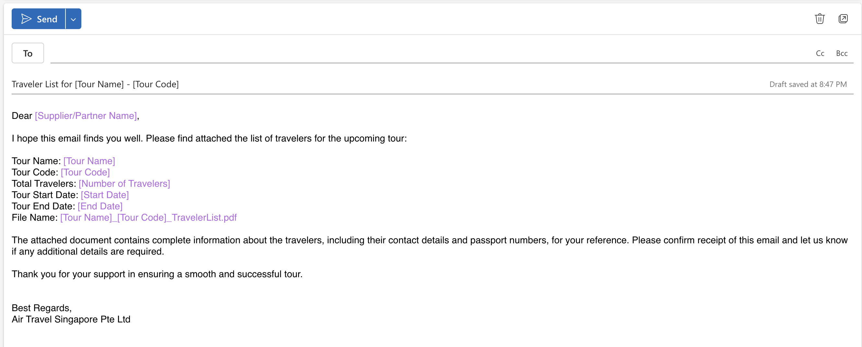

* 1. Attachment: Generated PDF file in Step 3.

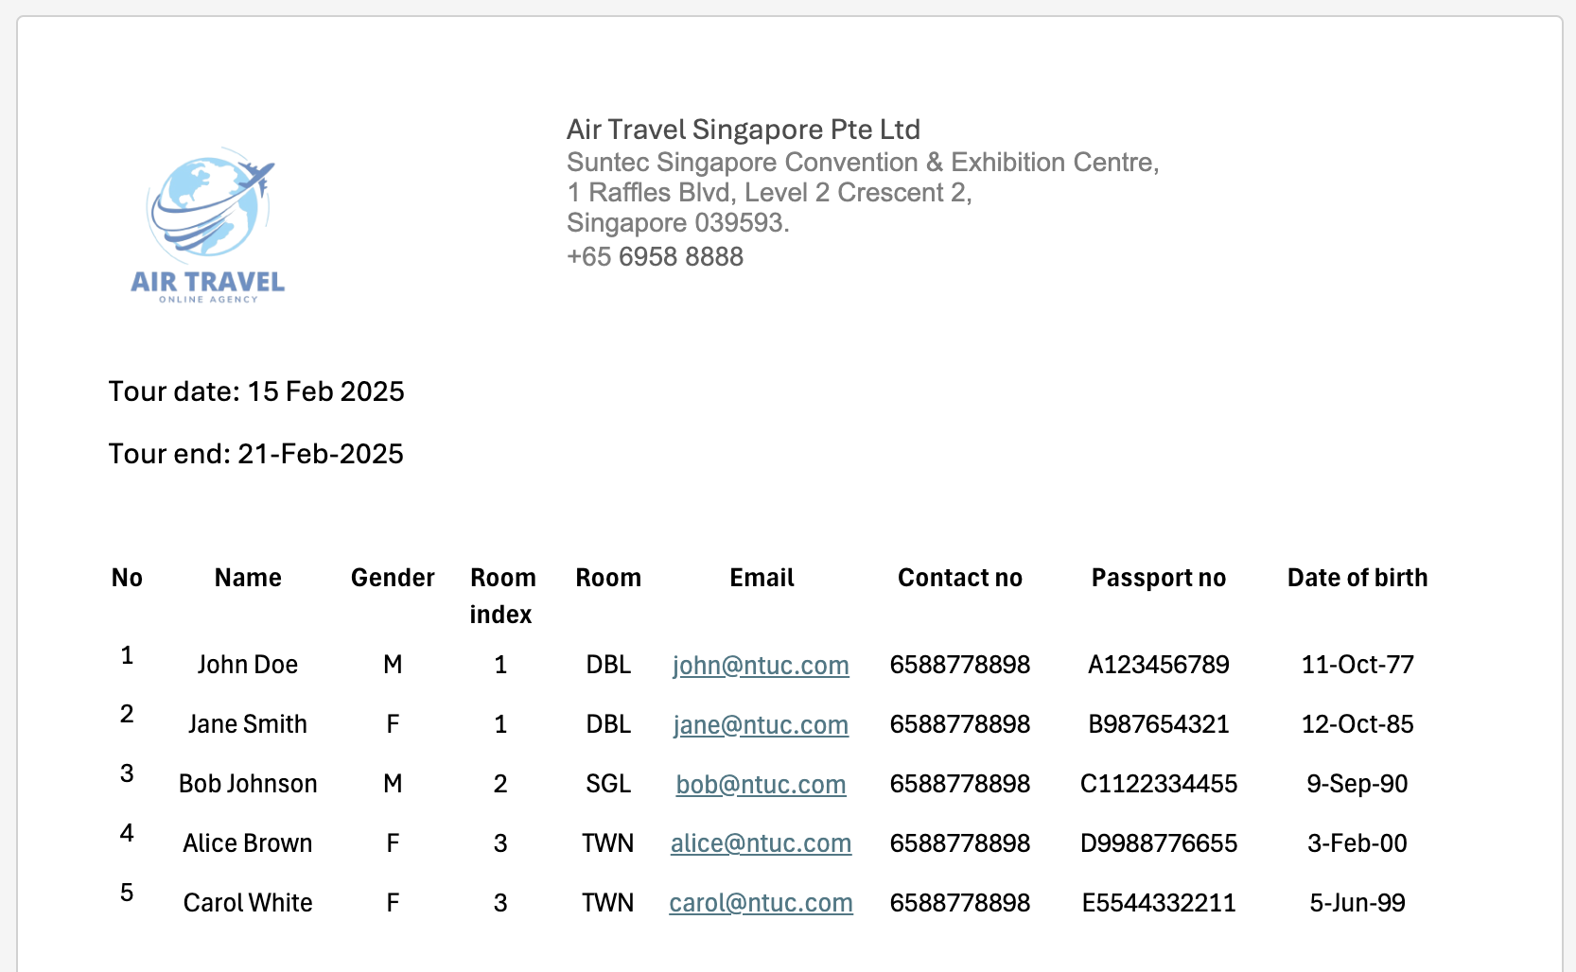

1. **Exception Handling** 
   1. Handle potential issues such as:
      1. No tours found for the specified start date.
      2. Missing or invalid customer details (e.g., passport expiry).
      3. Email sending failure (retry mechanism or admin notification).
2. **Logging and Reporting** 
   1. Maintain logs for each operation:
      1. Successful and failed operations (e.g., PDF generation, email sending).
      2. Number of customers processed per tour.
   2. Generate a summary report at the end of the process.

**Customer Reminder Workflow Description:**

1. **Calculate Reminder Date**
   1. Automatically set the reminder date as Today + 1 to identify tours starting tomorrow.
2. **Identify Matching Files**
   1. Search the working directory for Excel files containing _StartDate_ in the filename where StartDate equals the reminder date.
   2. Handle Scenarios:

* If no matching files are found: Log an error message, notify the admin, and terminate the process gracefully.
* If multiple files are found, process each file iteratively.

1. **Data Extraction and Preparation**  
   For each matching file:
   1. Open the Excel file and extract the following data:

* **Tour Information**: Tour Name, Start Date, End Date, Destination Country.
* **Customer List**: Customer ID, First Name, Last Name, Gender, Passport Number, Passport Expiry Date, Date of Birth, Contact Number, Rooming Group, Room Type.
* **Flight Details** (if applicable): Flight PNR, Departure Flight Details (Date, Time, Terminal).

1. **Fetch Additional Data**
   1. Weather Forecast: Use browser automation to fetch the weather forecast for the tour destination. Retrieve temperature range (Min-Max) for the tour duration.

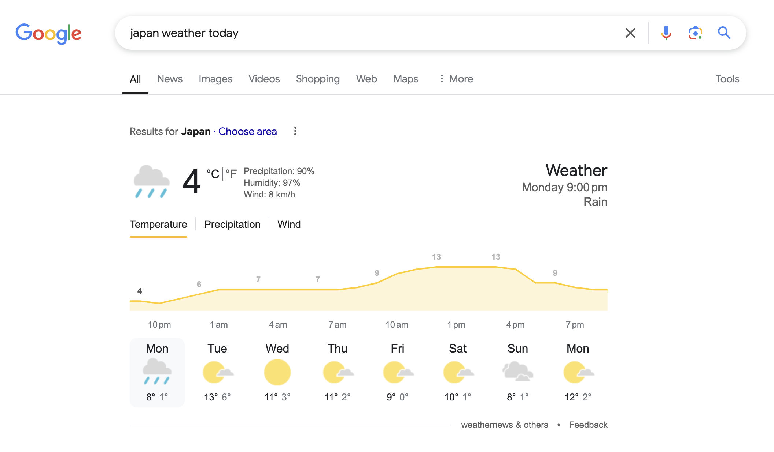

* 1. Flight Terminal Details: For customers with valid Flight PNR, use browser to retrieve the departure terminal details. Log any failures and skip if the terminal information that cannot be retrieved.

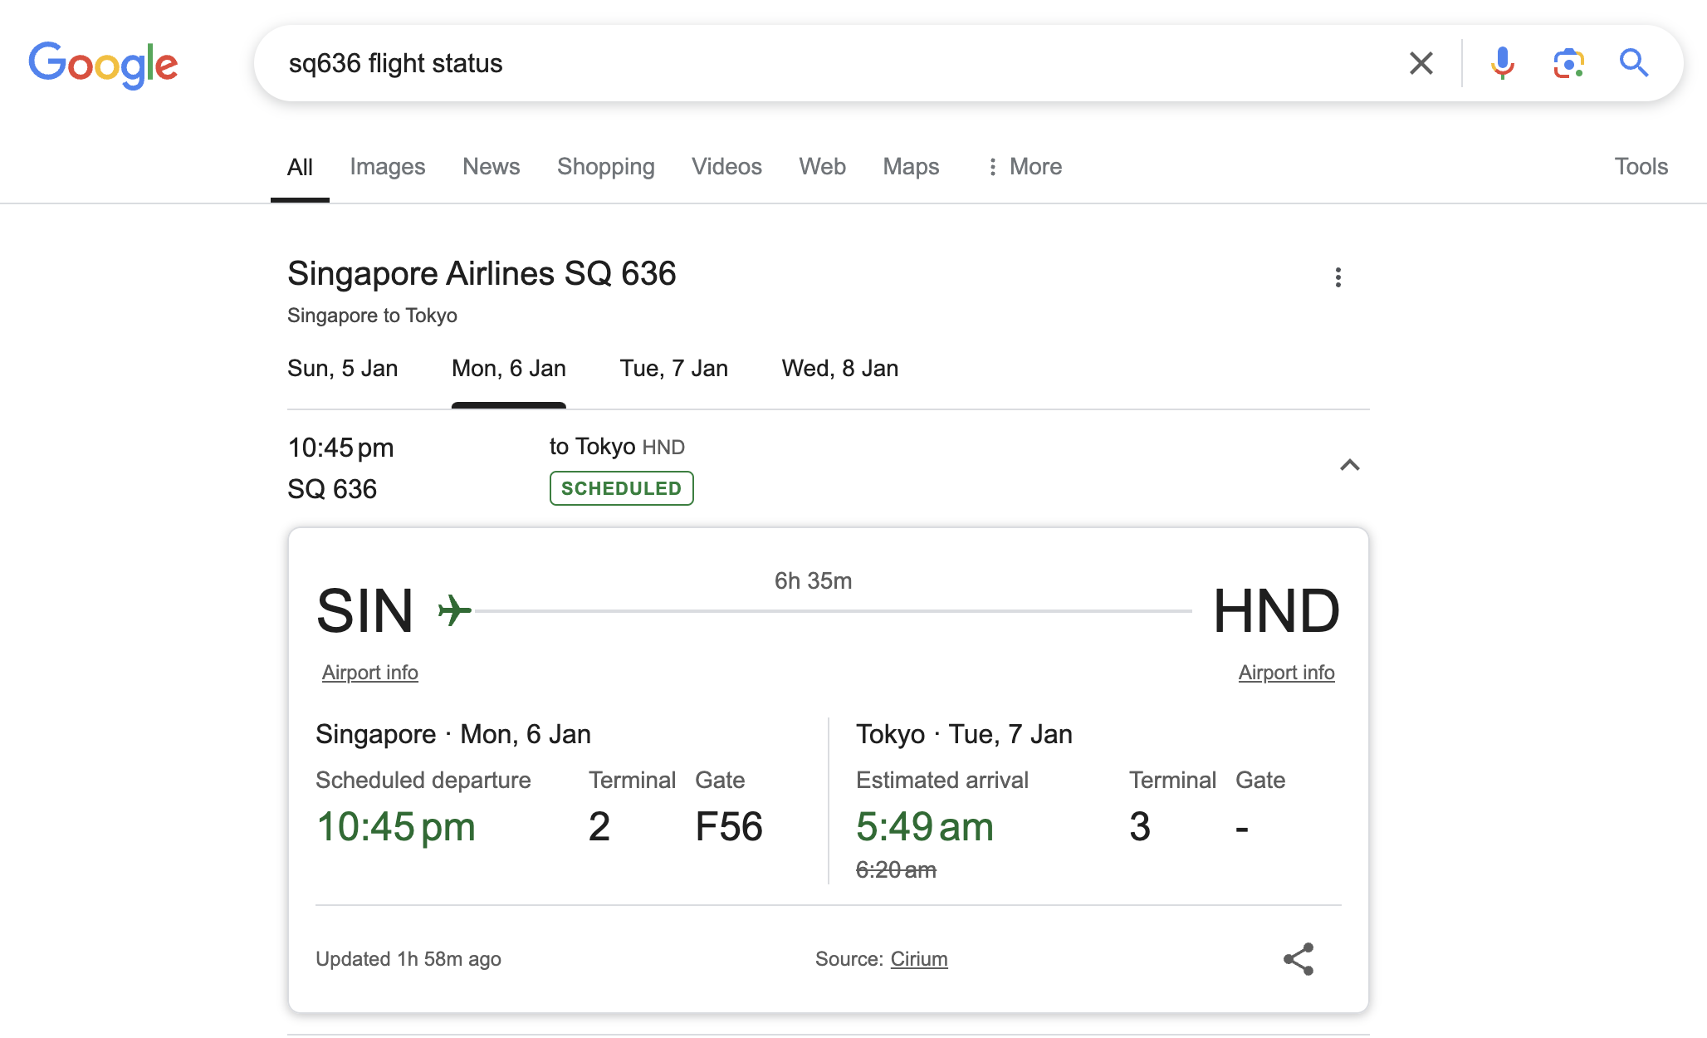

1. **Prepare and Send Reminders**
   1. Loop through each customer in the extracted data and prepare a personalized message using the template:

Message content values to be replace:

* Greeting (e.g., "Dear [First Name]").
* Tour Information: Tour Name, Start Date, Destination Country.
* Weather Forecast: Minimum and Maximum temperature.
* Flight departs time – 2 hours for check in time.
* Flight Details: Flight Number and Terminal (if available).

Message template:

Hello [Customer Name],

Reminder for your upcoming tour:

- Check in time: [Check in time]

- Scheduled departure time: [Departure time]

- Changi Airport [Terminal no]

- Flight: [Flight no]

- Weather: [Weather Details]

Thank you, Enjoy your tour

* 1. Send the message via web WhatsApp using browser automation.
* In browser address go to wa.me/[customer-contact-no] > Continue Chat > use WhatsApp Web. Then paste the message template in chat.

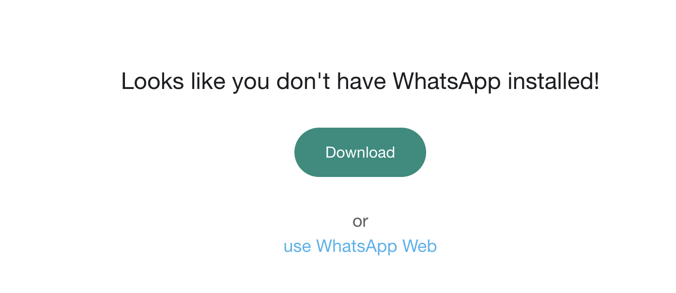

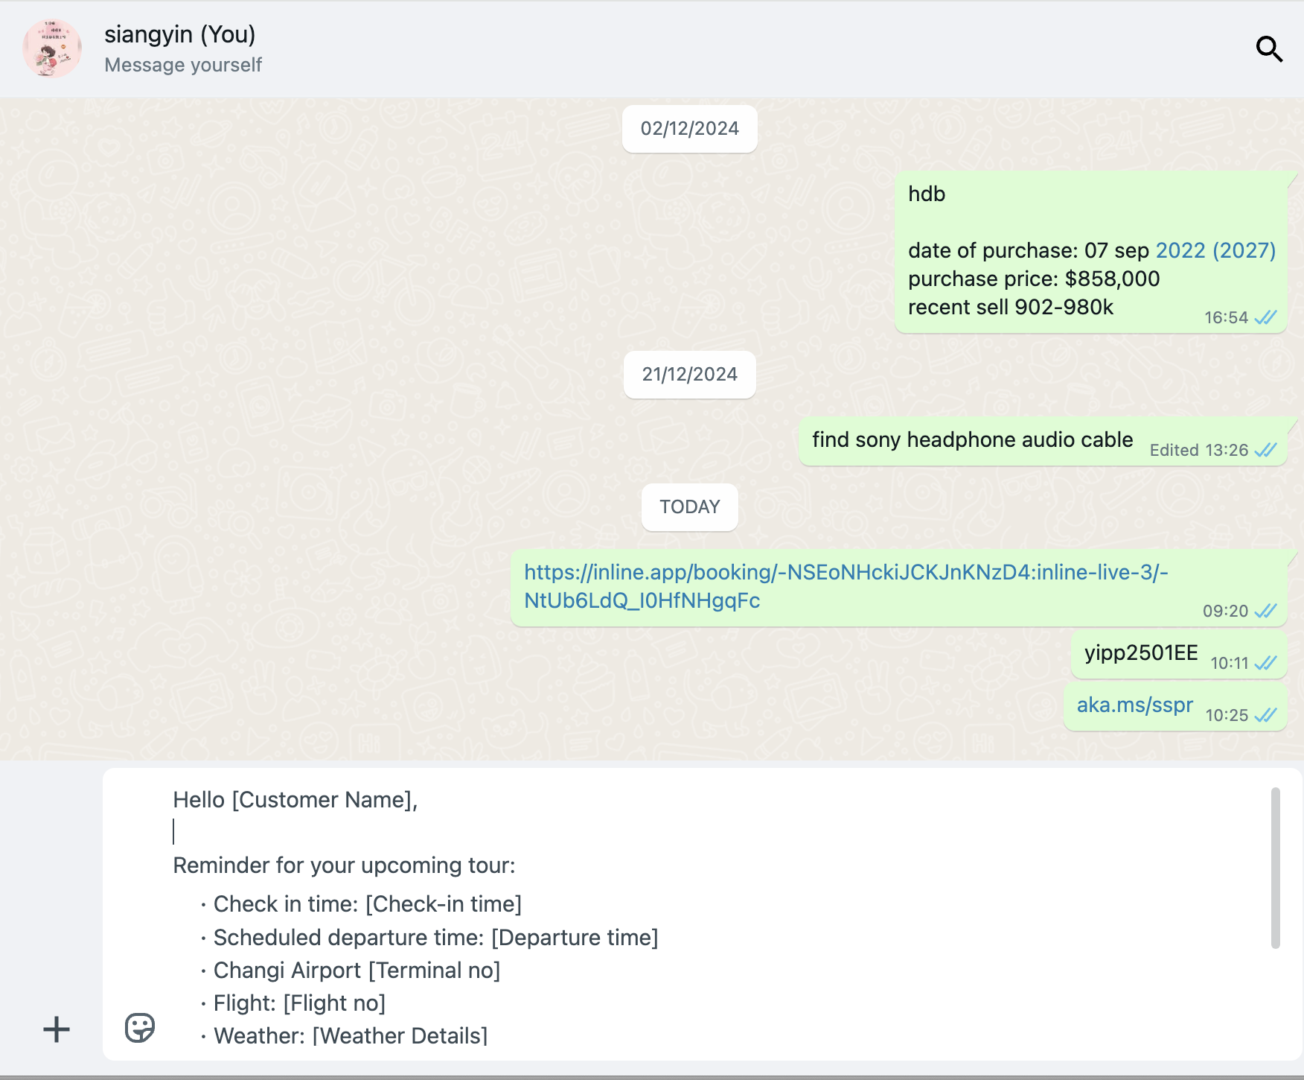

1. **Exception Handling**

Implement structured error handling for potential issues:

* Missing Data: Skip records with incomplete customer details (log and notify the admin).
* Weather/Flight Data Retrieval Failures: Log warning messages and proceed without the missing information.
* WhatsApp Message Failures: Log failed attempts and notifying the admin for manual intervention and continue.

1. **Logging and Reporting**
   1. Maintain a detailed log for each operation:

* Successful Operations: Record successful message delivery for each customer.
* Failed Operations: Capture errors in message delivery, data extraction, or data retrieval.
  1. Generate a summary report at the end of the process:
* Total number of tour notification processed.
* Number of successful reminders sent of each tour.
* Errors encountered (with details).
  1. Save the report as ReminderSummary_Report_[Date].xlsx.

**A. Data Preparation:**

1. **FilterBookingByStartDate**:

* **Purpose**: Extract bookings based on a specific date.
* **Input**: User-specified date. (TourStartDate)
* **Output**: Filtered bookings matching the given date (BookingByStartDate).
* **Use Cases**: Reuse for both PDF generation and customer reminder tasks.
* **Error Handling**: If no bookings match the date, log a warning, and notify the user.

1. **GetUniqueTourList**:

* **Purpose**: Generate a unique list of tours from BookingByStartDate (DataTable).
* **Input**: BookingByStartDate (DataTable).
* **Output**: Unique list of tours with customer counts and IDs (TourList). TourList (List of Dictionaries, e.g., [{TourId: T001, PaxNo: 5, CustomerIds: [...]}, ...]).
* **Use Cases**: Reuse for mapping agent details, compiling customer data, and generating reports.
* **Error Handling**: Validate that the BookingByStartDate table is not empty before processing.

1. **GetAgentDetails**:

* **Purpose**: Retrieve agent details for a given TourId.
* **Input**: TourId (String), TourData (DataTable).
* **Output**: Agent details for each tour in TourList. AgentDetails (Dictionary with fields like Name, Email, Contact).
* **Use Cases**: Reuse for email generation and other agent-related tasks.
* **Error Handling**: If no agent details are found, log the error, and proceed with partial data.

1. **GetCustomerDetails**:

* **Purpose**: Map customer details for a given list of CustomerIds.
* **Input**: CustomerIds (List of Strings), CustomerData (DataTable).
* **Output**: Customer information for each tour. CustomerDetails (DataTable).
* **Use Cases**: Reuse for PDF generation and reminder message preparation.
* **Error Handling**: Log missing CustomerIds and proceed with available data.

1. **SaveCompiledData**:

* **Purpose**: Save data into Excel files named [TourId_StartDate_EndDate].xlsx for reuse.

**B. Automation Task Execution:**

1. **GeneratePDF**:

* **Purpose**: Create structured PDFs with:
  + Tour Information: Tour Name, Start/End Dates.
  + Customer List: Full Name, Gender, Passport Details, Rooming Info, Flight Details.
* **Input**: TourData, CustomerDetails, OutputFilePath.
* **Output**: PDFs saved as [TourId_StartDate_EndDate].pdf to disk.
* **Use Cases**: Reuse for generating reports or attachments for email automation.
* **Error Handling**: Log error, notify the user.

1. **SendEmailToAgent**:

* **Purpose**: Email tour agent with booking details and attachments.
* **Input**: AgentDetails, PDFFilePath, EmailBodyTemplate.
* **Output**: Confirmation of email sent.
* **Use Cases**: Reuse for notifying agents about tour details.
* **Error Handling**: Log error, notify the user.

1. **GetWeatherDetails:**

* **Purpose**: Retrieve weather forecasts for a given destination and date range.
* **Input**: Destination (String), DateRange (StartDate and EndDate).
* **Output**: WeatherDetails (Min-Max Temperature).
* **Use Cases**: Reuse for both reminder automation and other weather-dependent tasks.
* **Error Handling**: Log error, notify the user.

1. **GetFlightTerminalDetails:**

* **Purpose**: Fetch flight terminal details using Flight No.
* **Input**: Flight No (String).
* **Output**: FlightTerminal (String or Null if not found).
* **Use Cases**: Reuse for sending flight-related reminders.
* **Error Handling**: Log error, notify the user.

1. **SendWhatsAppMessage**

* **Purpose**: Send a personalized reminder message via web WhatsApp.
* **Input**: CustomerContact, MessageContent.
* **Output**: Confirmation of message sent.
* **Use Cases**: Reuse for customer reminders and other notification tasks.
* **Error Handling**: Log error, notify the user.

**C. Reporting and Logging:**

1. **GenerateReport**

* **Purpose**: Maintain a detailed log for each operation.
  + Successful Operations: Record successful message delivery for each customer.
  + Failed Operations: Capture errors in message delivery, data extraction, or data retrieval.
  + Generate a summary report at the end of the process:
  + Total number of tour notification processed.
  + Number of successful reminders sent of each tour.
  + Errors encountered (with details).
* **Output**: ReminderSummary_Report_[Date].xlsx

**Tour Booking Coordination Flowchart Design**

**Customer Reminder Flowchart Design**

**Business Impact Assessment:**

1. **Time Saved:**

* Reduces manual effort by automating repetitive tasks like data consolidation and message delivery.
* Speeds up tour coordination processes by 70-80%.

1. **Error Reduction:**

* Validates data before processing, ensuring consistent and accurate in customer details and documents.
* Minimizes human errors in booking coordination.

1. **Productivity Improvements:**

* Scales to handle multiple tours and customers simultaneously without additional resources.
* Enables staff to focus on higher-value tasks, such as customer service.

**Conclusion:**

This automation project will streamline the coordination of tour bookings, improve operational efficiency, and deliver measurable business benefits in terms of time savings, error reduction, and productivity gains. The proposed solution ensures scalability, robustness, and compliance with best practices in RPA development.

**Deliverables:**

1. Completed UiPath workflows for:

* Data extraction.
* PDF generation.
* Email automation.

1. A sample dataset to simulate the process.
2. A generated PDF example for one tour.
3. A summary report showcasing the process results.
4. A user guide detailing setup, execution, and troubleshooting.

**Project Schedule:**

|  |  |
| --- | --- |
| Week 9 - 10 | Project idea concept and brainstorming |
| Week 11 - 12 | Proposal Drafting, with requirements gathering and dataset preparation. |
| Week 13 | Workflow Design |
| Week 14 | Development of Automation Tasks |
| Week 15 | PDF Generation and Email Automation Workflow |
| Week 16 | Reminder Notification and Web Scraping Automation |
| Week 17 | Testing, Debugging, and Optimization. |
| Week 18 | Documentation, Reporting and Final Presentation. |

**Approved** ◻**/ Rejected** ◻ **/Re-Submit** ◻

|  |
| --- |
| **IMPORTANT NOTE:**  Students must submit their **own work** and **not copy programs from fellow classmates or some other sources.** Failure to comply will result in disciplinary action. Also, if a project group is found to have submitted work done by another project group, both groups **WILL NOT** have any marks for their projects. Take note that the disciplinary action taken will depend on severity and can range from failing the affected component of the subject to suspension/removal from course. |